Sunscreen Permission Form
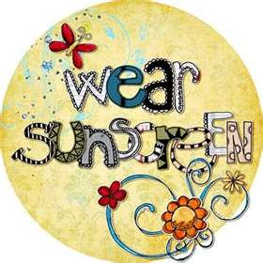
Tudorka Tots Infant & Preschool Centers
5040 Mountain Dr. Oakland, CA 94619
12000 Campus Dr. Oakland, CA 94619

I, _____________________ (parent/guardian), give Tudorka Tots permission to apply sunscreen to my child ______________________ (child’s name).
I understand sunscreen will only be applied in the afternoons and accept responsibility of applying morning sunscreen prior to my child’s daily attendance as needed.
□ Please only use ________________ brand, which I have provided.
□My child is not allergic to sunscreen. I have provided _______________ brand sunscreen, but any brand is ok to use.

Parent/ Guardian Signature _______________________ Date ________________

Sunscreen Permission Form
Tudorka Tots Infant & Preschool Centers
5040 Mountain Dr. Oakland, CA 94619
12000 Campus Dr. Oakland, CA 94619

I, _____________________ (parent/guardian), give Tudorka Tots permission to apply sunscreen to my child ______________________ (child’s name).
I understand sunscreen will only be applied in the afternoons and accept responsibility of applying morning sunscreen prior to my child’s daily attendance as needed.
□ Please only use ________________ brand, which I have provided.
□My child is not allergic to sunscreen. I have provided _______________ brand sunscreen, but any brand is ok to use.

Parent/ Guardian Signature _______________________ Date ________________

